Experiment 7: Travelling Salesman Problem

Aim:
To find the shortest possible route that visits each city exactly once and returns to the starting city using the Travelling Salesman Problem (TSP) algorithm.

Algorithm:
- Represent cities and distances in a matrix.
- Generate all possible paths (permutations of cities).
- Calculate total distance for each path.
- Choose the path with the minimum total distance.
- Display the shortest route and its cost.

Flowchart:

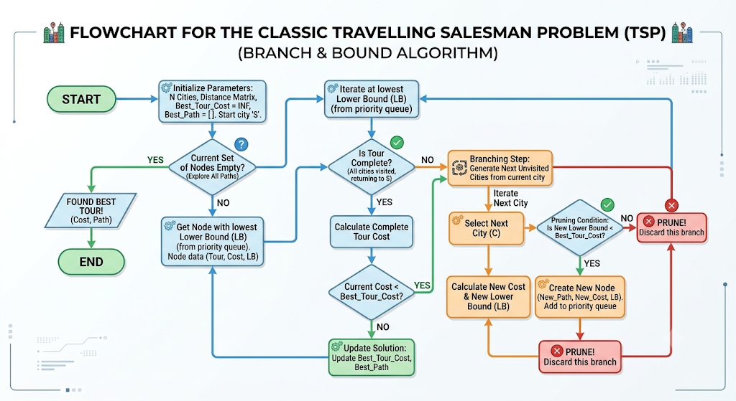

Source Code:

# Travelling Salesman Problem (TSP)
# Using Brute Force approach with permutations

from itertools import permutations

# Distance matrix (example for 4 cities) # 0 means same city, symmetric matrix dist_matrix = [
[0, 10, 15, 20],
[10, 0, 35, 25],
[15, 35, 0, 30],
[20, 25, 30, 0]
]

# Number of cities n = len(dist_matrix)
cities = list(range(n))

# Starting city (0) start = 0

# Initialize minimum path and cost min_cost = float('inf')
best_path = []

# Generate all possible paths excluding start city for perm in permutations(cities[1:]):

path = [start] + list(perm) + [start] cost = 0

# Calculate total cost for this path for i in range(len(path) - 1):
cost += dist_matrix[path[i]][path[i + 1]]

# Update minimum cost and path if cost < min_cost:
min_cost = cost best_path = path

# Display result
print("\n=== Travelling Salesman Problem ===") print("Shortest Path:", ' → '.join(map(str, best_path))) print("Minimum Cost:", min_cost)

Output:

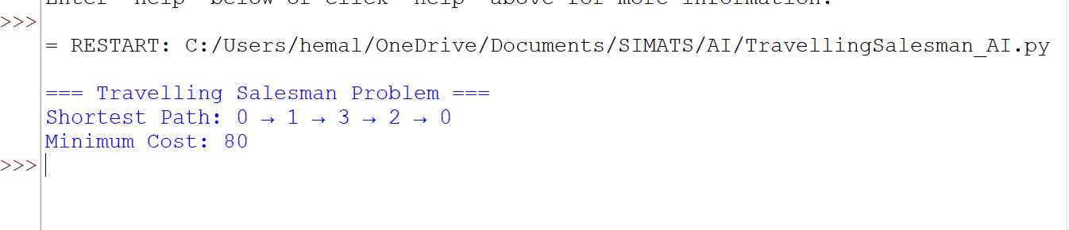

Result:

The Travelling Salesman Problem was successfully solved using the brute-force approach. The program finds the shortest route that visits all cities exactly once and returns to the starting city. The output displays both the optimal path and the minimum travel cost.

